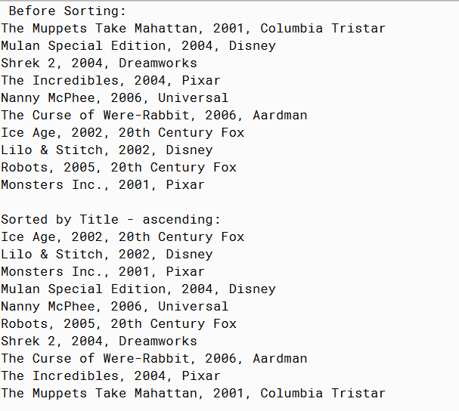

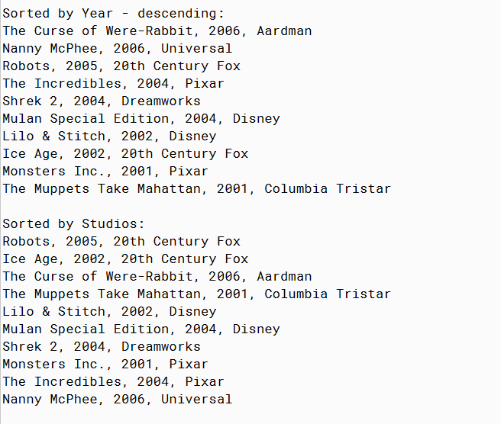

PMR: This assignment was relatively easy. It was easy since they already provide the code for the movie interface, but the tester was kind of hard to build. After looking at previous assignments and some help from the module it was easy to build. I enjoyed creating this assignment.

/\*\*

\* Movie Interface

\*

\* @author Anika Jallipalli

\* @version 4/11/2020

\*/

public class Movie2

{

private String title;

private int year;

private String studio;

public Movie2(String title, int year, String studio)

{

this.title = title;

this.year = year;

this.studio = studio;

}

public String toString()

{

String string = title + ", " + year + ", " + studio;

return string;

}

public String getTitle()

{

return title;

}

public int getYear()

{

return year;

}

public String getStudio()

{

return studio;

}

}

/\*\*

\* run the program

\*

\* @author Anika Jallipalli

\* @version 4/11/2020

\*/

public class TestMovie2

{

public static void main(String[] args)

{

Movie2 muppets = new Movie2("The Muppets Take Mahattan",2001,"Columbia Tristar");

Movie2 mulan = new Movie2("Mulan Special Edition",2004,"Disney");

Movie2 shrek = new Movie2("Shrek 2",2004,"Dreamworks");

Movie2 incredibles = new Movie2("The Incredibles",2004,"Pixar");

Movie2 nanny = new Movie2("Nanny McPhee",2006,"Universal");

Movie2 rabbit = new Movie2("The Curse of Were-Rabbit", 2006,"Aardman");

Movie2 iceage = new Movie2("Ice Age",2002,"20th Century Fox");

Movie2 lilo = new Movie2("Lilo & Stitch",2002,"Disney");

Movie2 robots = new Movie2("Robots",2005,"20th Century Fox");

Movie2 monsters = new Movie2("Monsters Inc.",2001,"Pixar");

Movie2[] movies = new Movie2[] {muppets, mulan, shrek, incredibles, nanny, rabbit,

iceage, lilo, robots, monsters};

Movie2[] newmovies = new Movie2[movies.length];

System.out.println("Before Sorting:");

printMovies(movies);

System.out.println();

System.out.println("Sorted by Title - ascending:");

newmovies = sortTitles(movies,1);

printMovies(newmovies);

System.out.println();

System.out.println("Sorted by Year - descending:");

newmovies = sortYears(movies,2);

printMovies(newmovies);

System.out.println();

System.out.println("Sorted by Studios:");

newmovies = sortStudios(movies,1);

printMovies(newmovies);

}

public static void printMovies(Movie2[] a)

{

for(int i=0;i< a.length;i++)

{

System.out.println(a[i].toString());

}

}

public static Movie2[] sortTitles(Movie2[] a, int b)

{

Movie2[] newlist = new Movie2[a.length];

if(b==1)

{

for(int i=0;i<a.length;i++)

{

String next = a[i].getTitle();

int insert = 0;

int k =i;

while(k>0 && insert == 0)

{

if(next.compareTo( newlist[k-1].getTitle() ) > 0)

{

insert = k;

}

else

{

newlist[k] = newlist[k-1];

}

k--;

}

newlist[insert]=a[i];

}

return newlist;

}

else if (b==2)

{

for(int i=0;i<a.length;i++)

{

String next = a[i].getTitle();

int insert = 0;

int k =i;

while(k>0 && insert == 0)

{

if(next.compareTo( newlist[k-1].getTitle() ) < 0)

{

insert = k;

}

else

{

newlist[k] = newlist[k-1];

}

k--;

}

newlist[insert]=a[i];

}

return newlist;

}

else

{

return newlist;

}

}

public static Movie2[] sortYears(Movie2[] a, int b)

{

Movie2[] newlist = new Movie2[a.length];

if(b==1)

{

for(int i=0;i<a.length;i++)

{

Movie2 next = a[i];

int insert = 0;

int k =i;

while(k>0 && insert == 0)

{

if(next.getYear() < newlist[k-1].getYear())

{

insert = k;

}

else

{

newlist[k] = newlist[k-1];

}

k--;

}

newlist[insert]=next;

}

return newlist;

}

else if (b==2)

{

for(int i=0;i<a.length;i++)

{

Movie2 next = a[i];

int insert = 0;

int k =i;

while(k>0 && insert == 0)

{

if(next.getYear() < newlist[k-1].getYear())

{

insert = k;

}

else

{

newlist[k] = newlist[k-1];

}

k--;

}

newlist[insert]=a[i];

}

return newlist;

}

else

{

return newlist;

}

}

public static Movie2[] sortStudios(Movie2[] a, int b)

{

Movie2[] newlist = new Movie2[a.length];

if(b==1)

{

for(int i=0;i<a.length;i++)

{

String next = a[i].getStudio();

int insert = 0;

int k =i;

while(k>0 && insert == 0)

{

if(next.compareTo( newlist[k-1].getStudio() ) > 0)

{

insert = k;

}

else

{

newlist[k] = newlist[k-1];

}

k--;

}

newlist[insert]=a[i];

}

return newlist;

}

else if (b==2)

{

for(int i=0;i<a.length;i++)

{

String next = a[i].getStudio();

int insert = 0;

int k =i;

while(k>0 && insert == 0)

{

if(next.compareTo( newlist[k-1].getStudio() ) < 0)

{

insert = k;

}

else

{

newlist[k] = newlist[k-1];

}

k--;

}

newlist[insert]=a[i];

}

return newlist;

}

else

{

return newlist;

}

}

}